Project Report

**Introduction:**

**Email** (electronic mail) is a way to **send and receive messages** across the Internet. It's similar to traditional mail, but it also has some key differences. To get a better idea of what email is all about, take a look at the infographic below and consider how you might benefit from its use.

**Purpose:**

email is a valuable tool, it creates some challenges for writers. Miscommunication can easily occur when people have different expectations about the messages that they send and receive. Email is used for many different purposes, including contacting friends, communicating with professors and supervisors, requesting information, and applying for jobs, internships, and scholarships. Depending on your purposes, the messages you send will differ in their formality, intended audience, and desired outcomes.

**Problem Definition and design thinking:**

**Empathy map:**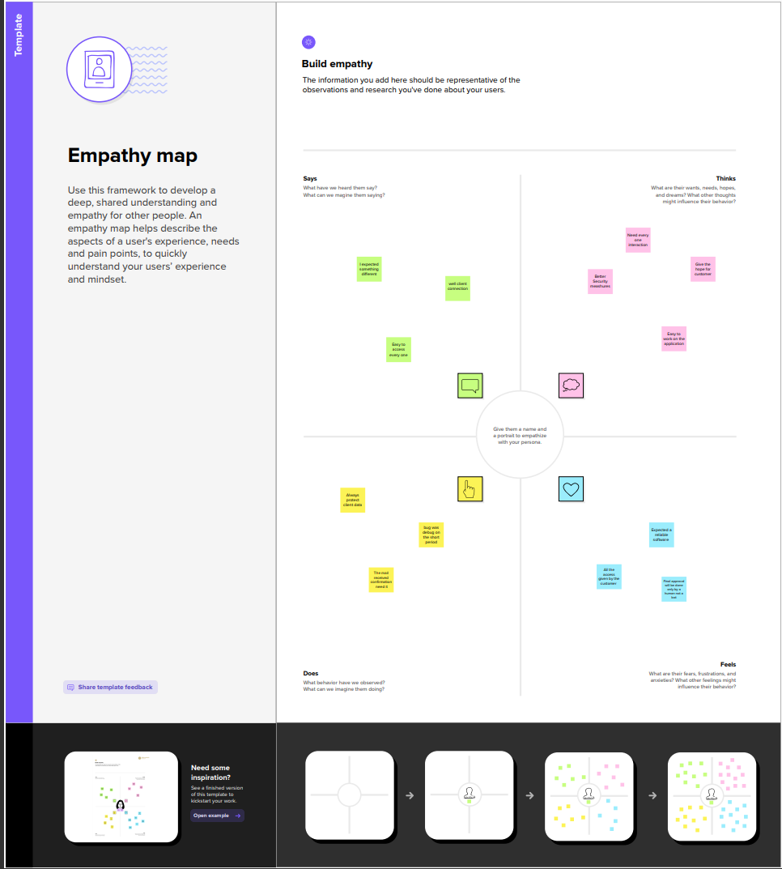

**deation & Brainstorming map:**

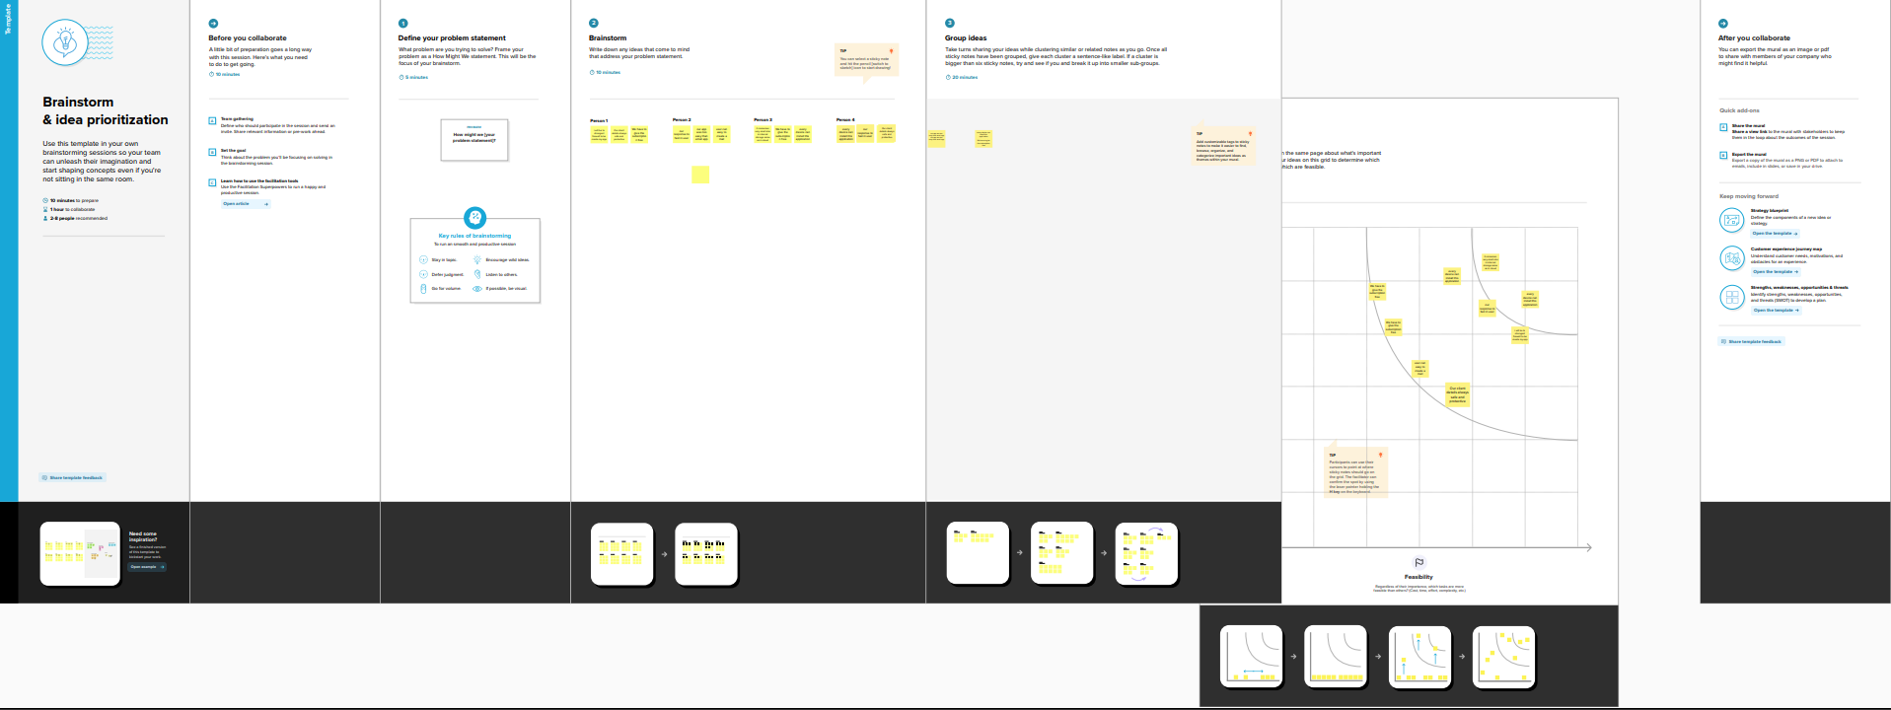

**Result:**

Login Page:

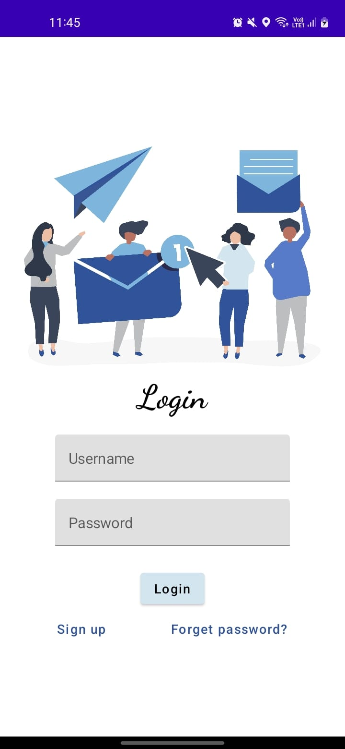

**Register Image:**

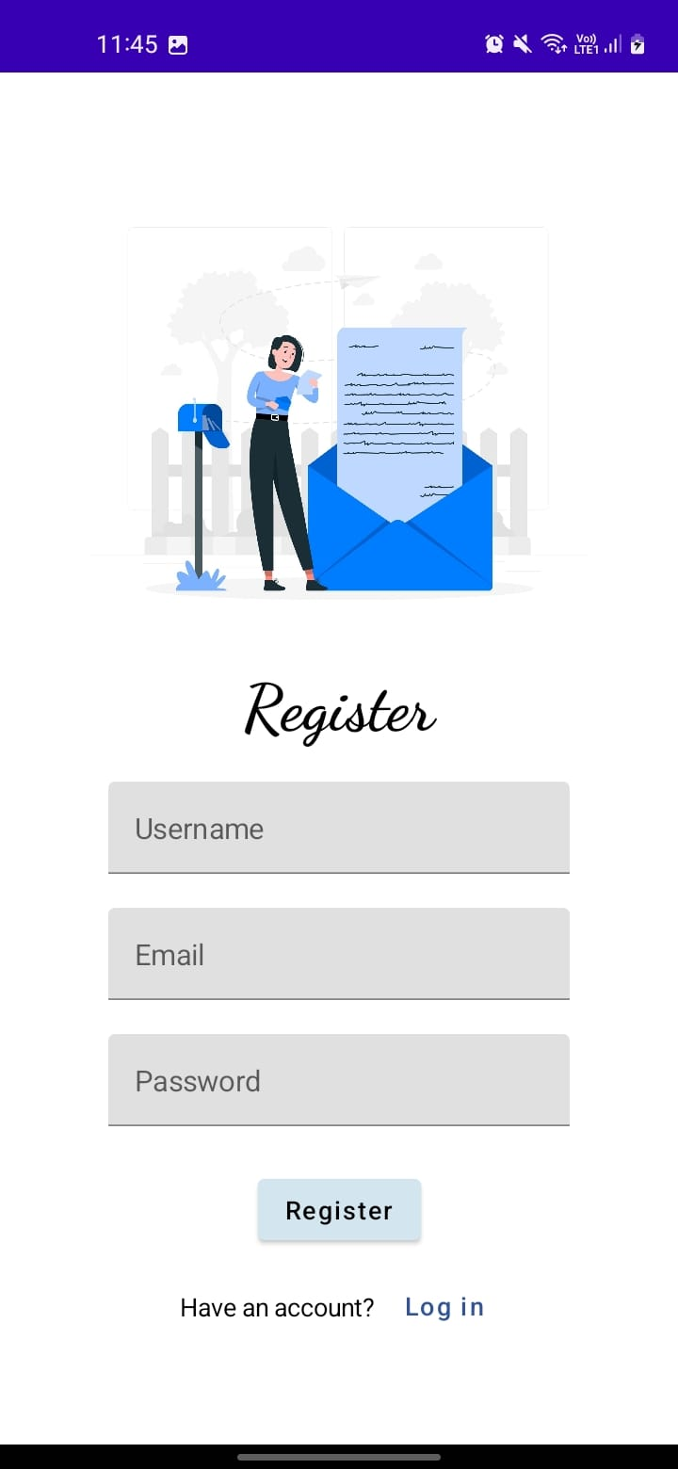

**Main Page:**

**Home Screen**

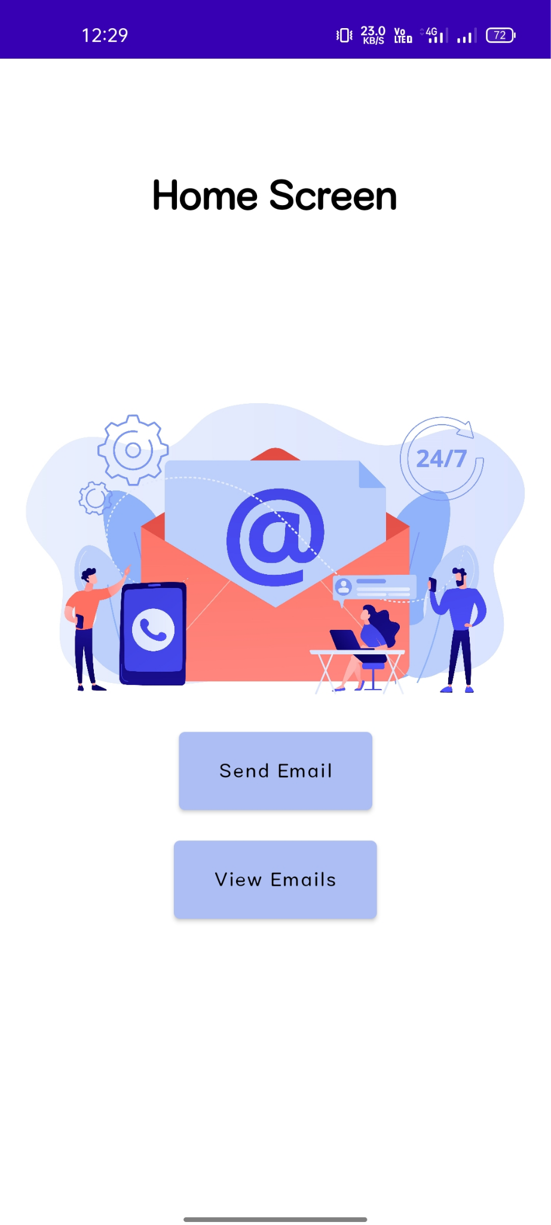

**View Mail Page:**

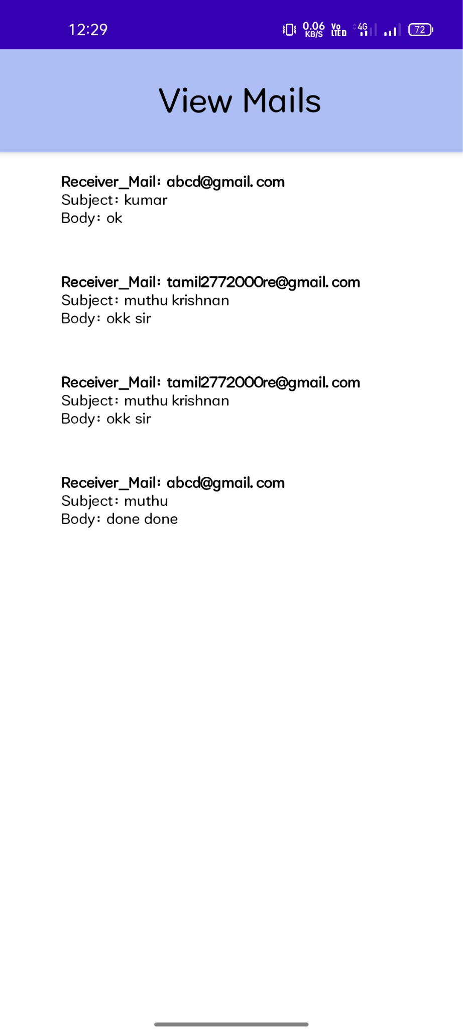

**Advantage:**

* productivity tools: Email is usually packaged with a calendar, address book, instant messaging, and more for convenience and productivity.
* Access to web services: If you want to sign up for an account like Facebook or order products from services like Amazon, you will need an email address so you can be safely identified and contacted.
* Easy mail management: Email service providers have tools that allow you to file, label, prioritize, find, group, and filter your emails for easy management. You can even easily control spam, or junk email.
* Privacy: Your email is delivered to your own personal and private account with a password required to access and view emails.
* Communication with multiple people: You can send an email to multiple people at once, giving you the option to include as few as or as many people as you want in a conversation.
* Accessible anywhere at any time: You don’t have to be at home to get your mail. You can access it from any computer or mobile device that has an Internet connection.

**Disadvantage:**

* Email could potentially cause information overload. ...
* Email lacks a personal touch. ...
* Email can be disruptive. ...
* Email cannot be ignored for a long time. ...
* Email can cause misunderstandings. ...
* Email messages can contain viruses.

**Application:**

Email is a very popular way of communicating with others over the Internet. An application that allows users to send, receive, and read email is called an *email client*. Red Hat Enterprise Linux includes several email applications, including graphical email clients like Evolution and Thunderbird, and text-based clients like mutt. Each of the email client applications is designed to suit specific types of users; so, you can choose one with the features that best suits your particular needs.

The purpose of this chapter is to demonstrate how to use some of the popular email applications included in Red Hat Enterprise Linux. Since all email clients perform the same basic tasks (send and receive email), you should choose one that is convenient and easy to use.

**Conclusion**:

This project provides more creative and innovative ideas for us. To know lots of things about android and Flexible email. Its helpful for creatine bond between team member.

**Future Scope:**

We break down some of the top trends and best practices that we see guiding the future of email. Staying on top of the latest innovations in the world of email will help your business communications remain effective. But the future of email looks bright: it's an essential tool for internal and external communications

**Appendix:**

### **Gradle scripts > build.gradle(Module :app)**

plugins **{**

id 'com.android.application'

id 'org.jetbrains.kotlin.android'

**}**

android **{**

namespace 'com.example.project'

compileSdk 33

defaultConfig **{**

applicationId "com.example.project"

minSdk 24

targetSdk 33

versionCode 1

versionName "1.0"

testInstrumentationRunner "androidx.test.runner.AndroidJUnitRunner"

vectorDrawables **{**

useSupportLibrary true

**}**

**}**

buildTypes **{**

release **{**

minifyEnabled false

proguardFiles getDefaultProguardFile('proguard-android-optimize.txt'), 'proguard-rules.pro'

**}**

**}**

compileOptions **{**

sourceCompatibility JavaVersion.*VERSION_1_8*

targetCompatibility JavaVersion.*VERSION_1_8*

**}**

kotlinOptions **{**

jvmTarget = '1.8'

**}**

buildFeatures **{**

compose true

**}**

composeOptions **{**

kotlinCompilerExtensionVersion '1.2.0'

**}**

packagingOptions **{**

resources **{**

excludes += '/META-INF/{AL2.0,LGPL2.1}'

**}**

**}**

**}**

dependencies **{**

implementation 'androidx.core:core-ktx:1.7.0'

implementation 'androidx.lifecycle:lifecycle-runtime-ktx:2.3.1'

implementation 'androidx.activity:activity-compose:1.3.1'

implementation "androidx.compose.ui:ui:$compose_ui_version"

implementation "androidx.compose.ui:ui-tooling-preview:$compose_ui_version"

implementation 'androidx.compose.material:material:1.2.0'

testImplementation 'junit:junit:4.13.2'

androidTestImplementation 'androidx.test.ext:junit:1.1.5'

androidTestImplementation 'androidx.test.espresso:espresso-core:3.5.1'

androidTestImplementation "androidx.compose.ui:ui-test-junit4:$compose_ui_version"

debugImplementation "androidx.compose.ui:ui-tooling:$compose_ui_version"

debugImplementation "androidx.compose.ui:ui-test-manifest:$compose_ui_version"

// Adding Room dependencies

implementation 'androidx.room:room-common:2.5.0'

implementation 'androidx.room:room-ktx:2.5.0'

**}**

**Adding User File:**

**package com.example.project**

**import androidx.room.ColumnInfo**

**import androidx.room.Entity**

**import androidx.room.PrimaryKey**

**@Entity(tableName = "user_table")**

**data class User(**

**@PrimaryKey(autoGenerate = true) val id: Int?,**

**@ColumnInfo(name = "first_name") val firstName: String?,**

**@ColumnInfo(name = "last_name") val lastName: String?,**

**@ColumnInfo(name = "email") val email: String?,**

**@ColumnInfo(name = "password") val password: String?,**

**)**

**Adding UserDao File:**

package com.example.project

import androidx.room.*

@Dao

interface UserDao {

@Query("SELECT * FROM user_table WHERE email = :email")

suspend fun getUserByEmail(email: String): User?

@Insert(onConflict = OnConflictStrategy.REPLACE)

suspend fun insertUser(user: User)

@Update

suspend fun updateUser(user: User)

@Delete

suspend fun deleteUser(user: User)

}

### **Adding UserDatabase:**

package com.example.project

import android.content.Context

import androidx.room.Database

import androidx.room.Room

import androidx.room.RoomDatabase

@Database(entities = [User::class], version = 1)

abstract class UserDatabase : RoomDatabase() {

abstract fun userDao(): UserDao

companion object {

@Volatile

private var instance: UserDatabase? = null

fun getDatabase(context: Context): UserDatabase {

return instance ?: *synchronized*(this) **{**

val newInstance = Room.databaseBuilder(

context.*applicationContext*,

UserDatabase::class.*java*,

"user_database"

).build()

instance = newInstance

newInstance

**}**

}

}

}

### **Adding UserDatabaseHelper:**

package com.example.project

import android.annotation.SuppressLint

import android.content.ContentValues

import android.content.Context

import android.database.Cursor

import android.database.sqlite.SQLiteDatabase

import android.database.sqlite.SQLiteOpenHelper

class UserDatabaseHelper(context: Context) :

SQLiteOpenHelper(context, DATABASE_NAME, null, DATABASE_VERSION) {

companion object {

private const val DATABASE_VERSION = 1

private const val DATABASE_NAME = "UserDatabase.db"

private const val TABLE_NAME = "user_table"

private const val COLUMN_ID = "id"

private const val COLUMN_FIRST_NAME = "first_name"

private const val COLUMN_LAST_NAME = "last_name"

private const val COLUMN_EMAIL = "email"

private const val COLUMN_PASSWORD = "password"

}

override fun onCreate(db: SQLiteDatabase?) {

val createTable = "CREATE TABLE $TABLE_NAME (" +

"$COLUMN_ID INTEGER PRIMARY KEY AUTOINCREMENT, " +

"$COLUMN_FIRST_NAME TEXT, " +

"$COLUMN_LAST_NAME TEXT, " +

"$COLUMN_EMAIL TEXT, " +

"$COLUMN_PASSWORD TEXT" +

")"

db?.execSQL(createTable)

}

override fun onUpgrade(db: SQLiteDatabase?, oldVersion: Int, newVersion: Int) {

db?.execSQL("DROP TABLE IF EXISTS $TABLE_NAME")

onCreate(db)

}

fun insertUser(user: User) {

val db = *writableDatabase*

val values = ContentValues()

values.put(COLUMN_FIRST_NAME, user.firstName)

values.put(COLUMN_LAST_NAME, user.lastName)

values.put(COLUMN_EMAIL, user.email)

values.put(COLUMN_PASSWORD, user.password)

db.insert(TABLE_NAME, null, values)

db.close()

}

@SuppressLint("Range")

fun getUserByUsername(username: String): User? {

val db = *readableDatabase*

val cursor: Cursor = db.rawQuery("SELECT * FROM $TABLE_NAME WHERE $COLUMN_FIRST_NAME = ?", *arrayOf*(username))

var user: User? = null

if (cursor.moveToFirst()) {

user = User(

id = cursor.getInt(cursor.getColumnIndex(COLUMN_ID)),

firstName = cursor.getString(cursor.getColumnIndex(COLUMN_FIRST_NAME)),

lastName = cursor.getString(cursor.getColumnIndex(COLUMN_LAST_NAME)),

email = cursor.getString(cursor.getColumnIndex(COLUMN_EMAIL)),

password = cursor.getString(cursor.getColumnIndex(COLUMN_PASSWORD)),

)

}

cursor.close()

db.close()

return user

}

@SuppressLint("Range")

fun getUserById(id: Int): User? {

val db = *readableDatabase*

val cursor: Cursor = db.rawQuery("SELECT * FROM $TABLE_NAME WHERE $COLUMN_ID = ?", *arrayOf*(id.toString()))

var user: User? = null

if (cursor.moveToFirst()) {

user = User(

id = cursor.getInt(cursor.getColumnIndex(COLUMN_ID)),

firstName = cursor.getString(cursor.getColumnIndex(COLUMN_FIRST_NAME)),

lastName = cursor.getString(cursor.getColumnIndex(COLUMN_LAST_NAME)),

email = cursor.getString(cursor.getColumnIndex(COLUMN_EMAIL)),

password = cursor.getString(cursor.getColumnIndex(COLUMN_PASSWORD)),

)

}

cursor.close()

db.close()

return user

}

@SuppressLint("Range")

fun getAllUsers(): List<User> {

val users = *mutableListOf*<User>()

val db = *readableDatabase*

val cursor: Cursor = db.rawQuery("SELECT * FROM $TABLE_NAME", null)

if (cursor.moveToFirst()) {

do {

val user = User(

id = cursor.getInt(cursor.getColumnIndex(COLUMN_ID)),

firstName = cursor.getString(cursor.getColumnIndex(COLUMN_FIRST_NAME)),

lastName = cursor.getString(cursor.getColumnIndex(COLUMN_LAST_NAME)),

email = cursor.getString(cursor.getColumnIndex(COLUMN_EMAIL)),

password = cursor.getString(cursor.getColumnIndex(COLUMN_PASSWORD)),

)

users.add(user)

} while (cursor.moveToNext())

}

cursor.close()

db.close()

return users

}

}

### **Adding Email data class:**

package com.example.project

import androidx.room.ColumnInfo

import androidx.room.Entity

import androidx.room.PrimaryKey

@Entity(tableName = "email_table")

data class Email(

@PrimaryKey(autoGenerate = true) val id: Int?,

@ColumnInfo(name = "receiver_mail") val recevierMail: String?,

@ColumnInfo(name = "subject") val subject: String?,

@ColumnInfo(name = "body") val body: String?,

)

### **Adding EmailDao interface:**

package com.example.project

import androidx.room.*

@Dao

interface EmailDao {

@Query("SELECT * FROM email_table WHERE subject= :subject")

suspend fun getOrderBySubject(subject: String): Email?

@Insert(onConflict = OnConflictStrategy.REPLACE)

suspend fun insertEmail(email: Email)

@Update

suspend fun updateEmail(email: Email)

@Delete

suspend fun deleteEmail(email: Email)

}

### **Adding EmailDatabase class:**

package com.example.project

import android.content.Context

import androidx.room.Database

import androidx.room.Room

import androidx.room.RoomDatabase

@Database(entities = [Email::class], version = 1)

abstract class EmailDatabase : RoomDatabase() {

abstract fun emailDao(): EmailDao

companion object {

@Volatile

private var instance: EmailDatabase? = null

fun getDatabase(context: Context): EmailDatabase {

return instance ?: *synchronized*(this) **{**

val newInstance = Room.databaseBuilder(

context.*applicationContext*,

EmailDatabase::class.*java*,

"email_database"

).build()

instance = newInstance

newInstance

**}**

}

}

}

### **Adding EmailDatabaseHelper class:**

package com.example.project

import android.annotation.SuppressLint

import android.content.ContentValues

import android.content.Context

import android.database.Cursor

import android.database.sqlite.SQLiteDatabase

import android.database.sqlite.SQLiteOpenHelper

class EmailDatabaseHelper(context: Context) :

SQLiteOpenHelper(context, DATABASE_NAME, null,DATABASE_VERSION){

companion object {

private const val DATABASE_VERSION = 1

private const val DATABASE_NAME = "EmailDatabase.db"

private const val TABLE_NAME = "email_table"

private const val COLUMN_ID = "id"

private const val COLUMN_RECEIVER_MAIL = "receiver_mail"

private const val COLUMN_SUBJECT = "subject"

private const val COLUMN_BODY = "body"

}

override fun onCreate(db: SQLiteDatabase?) {

val createTable = "CREATE TABLE $TABLE_NAME (" +

"${COLUMN_ID} INTEGER PRIMARY KEY AUTOINCREMENT, " +

"${COLUMN_RECEIVER_MAIL} Text, " +

"${COLUMN_SUBJECT} TEXT ," +

"${COLUMN_BODY} TEXT " +

")"

db?.execSQL(createTable)

}

override fun onUpgrade(db: SQLiteDatabase?, oldVersion: Int, newVersion: Int) {

db?.execSQL("DROP TABLE IF EXISTS $TABLE_NAME")

onCreate(db)

}

fun insertEmail(email: Email) {

val db = *writableDatabase*

val values = ContentValues()

values.put(COLUMN_RECEIVER_MAIL, email.recevierMail)

values.put(COLUMN_SUBJECT, email.subject)

values.put(COLUMN_BODY, email.body)

db.insert(TABLE_NAME, null, values)

db.close()

}

@SuppressLint("Range")

fun getEmailBySubject(subject: String): Email? {

val db = *readableDatabase*

val cursor: Cursor = db.rawQuery("SELECT * FROM $TABLE_NAME WHERE $COLUMN_SUBJECT = ?", *arrayOf*(subject))

var email: Email? = null

if (cursor.moveToFirst()) {

email = Email(

id = cursor.getInt(cursor.getColumnIndex(COLUMN_ID)),

recevierMail = cursor.getString(cursor.getColumnIndex(COLUMN_RECEIVER_MAIL)),

subject = cursor.getString(cursor.getColumnIndex(COLUMN_SUBJECT)),

body = cursor.getString(cursor.getColumnIndex(COLUMN_BODY)),

)

}

cursor.close()

db.close()

return email

}

@SuppressLint("Range")

fun getEmailById(id: Int): Email? {

val db = *readableDatabase*

val cursor: Cursor = db.rawQuery("SELECT * FROM $TABLE_NAME WHERE $COLUMN_ID = ?", *arrayOf*(id.toString()))

var email: Email? = null

if (cursor.moveToFirst()) {

email = Email(

id = cursor.getInt(cursor.getColumnIndex(COLUMN_ID)),

recevierMail = cursor.getString(cursor.getColumnIndex(COLUMN_RECEIVER_MAIL)),

subject = cursor.getString(cursor.getColumnIndex(COLUMN_SUBJECT)),

body = cursor.getString(cursor.getColumnIndex(COLUMN_BODY)),

)

}

cursor.close()

db.close()

return email

}

@SuppressLint("Range")

fun getAllEmails(): List<Email> {

val emails = *mutableListOf*<Email>()

val db = *readableDatabase*

val cursor: Cursor = db.rawQuery("SELECT * FROM $TABLE_NAME", null)

if (cursor.moveToFirst()) {

do {

val email = Email(

id = cursor.getInt(cursor.getColumnIndex(COLUMN_ID)),

recevierMail = cursor.getString(cursor.getColumnIndex(COLUMN_RECEIVER_MAIL)),

subject = cursor.getString(cursor.getColumnIndex(COLUMN_SUBJECT)),

body = cursor.getString(cursor.getColumnIndex(COLUMN_BODY)),

)

emails.add(email)

} while (cursor.moveToNext())

}

cursor.close()

db.close()

return emails

}

}

### **Adding LoginActivity.kt with database:**

package com.example.project

import android.content.Context

import android.content.Intent

import android.os.Bundle

import androidx.activity.ComponentActivity

import androidx.activity.compose.setContent

import androidx.compose.foundation.Image

import androidx.compose.foundation.background

import androidx.compose.foundation.layout.*

import androidx.compose.material.*

import androidx.compose.runtime.*

import androidx.compose.ui.Alignment

import androidx.compose.ui.Modifier

import androidx.compose.ui.graphics.Color

import androidx.compose.ui.layout.ContentScale

import androidx.compose.ui.res.painterResource

import androidx.compose.ui.text.font.FontFamily

import androidx.compose.ui.text.font.FontWeight

import androidx.compose.ui.text.input.PasswordVisualTransformation

import androidx.compose.ui.tooling.preview.Preview

import androidx.compose.ui.unit.dp

import androidx.compose.ui.unit.sp

import androidx.core.content.ContextCompat

import com.example.project.MainActivity

import com.example.project.R

import com.example.project.UserDatabaseHelper

class LoginActivity : ComponentActivity() {

private lateinit var databaseHelper: UserDatabaseHelper

override fun onCreate(savedInstanceState: Bundle?) {

super.onCreate(savedInstanceState)

databaseHelper = UserDatabaseHelper(this)

*setContent* **{**

*LoginScreen*(this, databaseHelper)

**}**

}

}

@Composable

fun LoginScreen(context: Context, databaseHelper: UserDatabaseHelper) {

var username by *remember* **{** *mutableStateOf*("") **}**

var password by *remember* **{** *mutableStateOf*("") **}**

var error by *remember* **{** *mutableStateOf*("") **}**

*Column*(

modifier = Modifier.*fillMaxSize*().*background*(Color.White),

horizontalAlignment = Alignment.CenterHorizontally,

verticalArrangement = Arrangement.Center

) **{**

*Image*(

*painterResource*(id = R.drawable.*email_login*), contentDescription = ""

)

*Text*(

fontSize = 36.*sp*,

fontWeight = FontWeight.ExtraBold,

fontFamily = FontFamily.Cursive,

text = "Login"

)

*Spacer*(modifier = Modifier.*height*(10.*dp*))

*TextField*(

value = username,

onValueChange = **{** username = **it }**,

label = **{** *Text*("Username") **}**,

modifier = Modifier.*padding*(10.*dp*)

.*width*(280.*dp*)

)

*TextField*(

value = password,

onValueChange = **{** password = **it }**,

label = **{** *Text*("Password") **}**,

visualTransformation = PasswordVisualTransformation(),

modifier = Modifier.*padding*(10.*dp*)

.*width*(280.*dp*)

)

if (error.*isNotEmpty*()) {

*Text*(

text = error,

color = MaterialTheme.colors.error,

modifier = Modifier.*padding*(vertical = 16.*dp*)

)

}

*Button*(

onClick = **{**

if (username.*isNotEmpty*() && password.*isNotEmpty*()) {

val user = databaseHelper.getUserByUsername(username)

if (user != null && user.password == password) {

error = "Successfully log in"

context.startActivity(

Intent(

context,

MainActivity::class.*java*

)

)

//onLoginSuccess()

}

} else {

error = "Please fill all fields"

}

**}**,

colors = ButtonDefaults.buttonColors(backgroundColor = *Color*(0xFFd3e5ef)),

modifier = Modifier.*padding*(top = 16.*dp*)

) **{**

*Text*(text = "Login")

**}**

*Row* **{**

*TextButton*(onClick = **{**context.startActivity(

Intent(

context,

RegisterActivity::class.*java*

)

)**}**

)

**{** *Text*(color = *Color*(0xFF31539a),text = "Sign up") **}**

*TextButton*(onClick = **{**

**}**)

**{**

*Spacer*(modifier = Modifier.*width*(60.*dp*))

*Text*(color = *Color*(0xFF31539a),text = "Forget password?")

**}**

**}**

**}**

}

private fun startMainPage(context: Context) {

val intent = Intent(context, MainActivity::class.*java*)

ContextCompat.startActivity(context, intent, null)

}

### **Adding RegisterActivity.kt with database:**

package com.example.project

import android.content.Context

import android.content.Intent

import android.os.Bundle

import androidx.activity.ComponentActivity

import androidx.activity.compose.setContent

import androidx.compose.foundation.Image

import androidx.compose.foundation.background

import androidx.compose.foundation.layout.*

import androidx.compose.material.*

import androidx.compose.runtime.*

import androidx.compose.ui.Alignment

import androidx.compose.ui.Modifier

import androidx.compose.ui.graphics.Color

import androidx.compose.ui.layout.ContentScale

import androidx.compose.ui.res.painterResource

import androidx.compose.ui.text.font.FontFamily

import androidx.compose.ui.text.font.FontWeight

import androidx.compose.ui.text.input.PasswordVisualTransformation

import androidx.compose.ui.tooling.preview.Preview

import androidx.compose.ui.unit.dp

import androidx.compose.ui.unit.sp

import androidx.core.content.ContextCompat

import com.example.project.R

import com.example.project.UserDatabaseHelper

class RegisterActivity : ComponentActivity() {

private lateinit var databaseHelper: UserDatabaseHelper

override fun onCreate(savedInstanceState: Bundle?) {

super.onCreate(savedInstanceState)

databaseHelper = UserDatabaseHelper(this)

*setContent* **{**

*RegistrationScreen*(this, databaseHelper)

**}**

}

}

@Composable

fun RegistrationScreen(context: Context, databaseHelper: UserDatabaseHelper) {

var username by *remember* **{** *mutableStateOf*("") **}**

var password by *remember* **{** *mutableStateOf*("") **}**

var email by *remember* **{** *mutableStateOf*("") **}**

var error by *remember* **{** *mutableStateOf*("") **}**

*Column*(

modifier = Modifier.*fillMaxSize*().*background*(Color.White),

horizontalAlignment = Alignment.CenterHorizontally,

verticalArrangement = Arrangement.Center

) **{**

*Image*(

*painterResource*(id = R.drawable.*email_signup*), contentDescription = "",

modifier = Modifier.*height*(300.*dp*)

)

*Text*(

fontSize = 36.*sp*,

fontWeight = FontWeight.ExtraBold,

fontFamily = FontFamily.Cursive,

text = "Register"

)

*Spacer*(modifier = Modifier.*height*(10.*dp*))

*TextField*(

value = username,

onValueChange = **{** username = **it }**,

label = **{** *Text*("Username") **}**,

modifier = Modifier

.*padding*(10.*dp*)

.*width*(280.*dp*)

)

*TextField*(

value = email,

onValueChange = **{** email = **it }**,

label = **{** *Text*("Email") **}**,

modifier = Modifier

.*padding*(10.*dp*)

.*width*(280.*dp*)

)

*TextField*(

value = password,

onValueChange = **{** password = **it }**,

label = **{** *Text*("Password") **}**,

visualTransformation = PasswordVisualTransformation(),

modifier = Modifier

.*padding*(10.*dp*)

.*width*(280.*dp*)

)

if (error.*isNotEmpty*()) {

*Text*(

text = error,

color = MaterialTheme.colors.error,

modifier = Modifier.*padding*(vertical = 16.*dp*)

)

}

*Button*(

onClick = **{**

if (username.*isNotEmpty*() && password.*isNotEmpty*() && email.*isNotEmpty*()) {

val user = User(

id = null,

firstName = username,

lastName = null,

email = email,

password = password

)

databaseHelper.insertUser(user)

error = "User registered successfully"

// Start LoginActivity using the current context

context.startActivity(

Intent(

context,

LoginActivity::class.*java*

)

)

} else {

error = "Please fill all fields"

}

**}**,

colors = ButtonDefaults.buttonColors(backgroundColor = *Color*(0xFFd3e5ef)),

modifier = Modifier.*padding*(top = 16.*dp*)

) **{**

*Text*(text = "Register")

**}**

*Spacer*(modifier = Modifier.*width*(10.*dp*))

*Spacer*(modifier = Modifier.*height*(10.*dp*))

*Row*() **{**

*Text*(

modifier = Modifier.*padding*(top = 14.*dp*), text = "Have an account?"

)

*TextButton*(onClick = **{**

context.startActivity(

Intent(

context,

LoginActivity::class.*java*

)

)

**}**)

**{**

*Spacer*(modifier = Modifier.*width*(10.*dp*))

*Text*(color = *Color*(0xFF31539a),text = "Log in")

**}**

**}**

**}**

}

private fun startLoginActivity(context: Context) {

val intent = Intent(context, LoginActivity::class.*java*)

ContextCompat.startActivity(context, intent, null)

}

### **Adding MainActivity.kt file:**

package com.example.project

import android.content.Context

import android.content.Intent

import android.os.Bundle

import androidx.activity.ComponentActivity

import androidx.activity.compose.setContent

import androidx.compose.foundation.Image

import androidx.compose.foundation.background

import androidx.compose.foundation.layout.*

import androidx.compose.material.*

import androidx.compose.runtime.Composable

import androidx.compose.ui.Alignment

import androidx.compose.ui.Modifier

import androidx.compose.ui.graphics.Color

import androidx.compose.ui.layout.ContentScale

import androidx.compose.ui.res.painterResource

import androidx.compose.ui.text.font.FontWeight

import androidx.compose.ui.tooling.preview.Preview

import androidx.compose.ui.unit.dp

import androidx.compose.ui.unit.sp

import androidx.core.content.ContextCompat

import androidx.core.content.ContextCompat.startActivity

class MainActivity : ComponentActivity() {

override fun onCreate(savedInstanceState: Bundle?) {

super.onCreate(savedInstanceState)

*setContent* **{**

// A surface container using the 'background' color from the theme

*Surface*(

modifier = Modifier.*fillMaxSize*().*background*(Color.White),

) **{**

*Email*(this)

**}**

**}**

}

}

@Composable

fun Email(context: Context) {

*Text*(

text = "Home Screen",

modifier = Modifier.*padding*(top = 74.*dp*, start = 100.*dp*, bottom = 24.*dp*),

color = Color.Black,

fontWeight = FontWeight.Bold,

fontSize = 32.*sp*

)

*Column*(

horizontalAlignment = Alignment.CenterHorizontally,

verticalArrangement = Arrangement.Center

) **{**

*Image*(

*painterResource*(id = R.drawable.*home_screen*), contentDescription = ""

)

*Button*(onClick = **{**

context.startActivity(

Intent(

context,

SendMailActivity::class.*java*

)

)

**}**,

colors = ButtonDefaults.buttonColors(backgroundColor = *Color*(0xFFadbef4))

) **{**

*Text*(

text = "Send Email",

modifier = Modifier.*padding*(10.*dp*),

color = Color.Black,

fontSize = 15.*sp*

)

**}**

*Spacer*(modifier = Modifier.*height*(20.*dp*))

*Button*(onClick = **{**

context.startActivity(

Intent(

context,

ViewMailActivity::class.*java*

)

)

**}**,

colors = ButtonDefaults.buttonColors(backgroundColor = *Color*(0xFFadbef4))

) **{**

*Text*(

text = "View Emails",

modifier = Modifier.*padding*(10.*dp*),

color = Color.Black,

fontSize = 15.*sp*

)

**}**

**}**

}

### **Adding SendMailActivity.kt file:**

package com.example.project

import android.annotation.SuppressLint

import android.content.Context

import android.content.Intent

import android.os.Bundle

import androidx.activity.ComponentActivity

import androidx.activity.compose.setContent

import androidx.compose.foundation.layout.*

import androidx.compose.material.*

import androidx.compose.runtime.*

import androidx.compose.ui.Alignment

import androidx.compose.ui.Modifier

import androidx.compose.ui.graphics.Color

import androidx.compose.ui.platform.*LocalContext*

import androidx.compose.ui.text.TextStyle

import androidx.compose.ui.text.font.FontWeight

import androidx.compose.ui.text.style.TextAlign

import androidx.compose.ui.tooling.preview.Preview

import androidx.compose.ui.unit.dp

import androidx.compose.ui.unit.sp

import com.example.project.Email

class SendMailActivity : ComponentActivity() {

private lateinit var databaseHelper: EmailDatabaseHelper

@SuppressLint("UnusedMaterialScaffoldPaddingParameter")

override fun onCreate(savedInstanceState: Bundle?) {

super.onCreate(savedInstanceState)

databaseHelper = EmailDatabaseHelper(this)

*setContent* **{**

*Scaffold*(

// in scaffold we are specifying top bar.

topBar = **{**

// inside top bar we are specifying

// background color.

*TopAppBar*(backgroundColor = *Color*(0xFFadbef4), modifier = Modifier.*height*(80.*dp*),

// along with that we are specifying

// title for our top bar.

title = **{**

// in the top bar we are specifying

// title as a text

*Text*(

// on below line we are specifying

// text to display in top app bar.

text = "Send Mail",

fontSize = 32.*sp*,

color = Color.Black,

// on below line we are specifying

// modifier to fill max width.

modifier = Modifier.*fillMaxWidth*(),

// on below line we are

// specifying text alignment.

textAlign = TextAlign.Center,

)

**}**

)

**}**

) **{**

// on below line we are

// calling method to display UI.

*openEmailer*(this,databaseHelper)

**}**

**}**

}

}

@Composable

fun openEmailer(context: Context, databaseHelper: EmailDatabaseHelper) {

// in the below line, we are

// creating variables for URL

var recevierMail by *remember* **{***mutableStateOf*("") **}**

var subject by *remember* **{***mutableStateOf*("") **}**

var body by *remember* **{***mutableStateOf*("") **}**

var error by *remember* **{** *mutableStateOf*("") **}**

// on below line we are creating

// a variable for a context

val ctx = *LocalContext*.current

// on below line we are creating a column

*Column*(

// on below line we are specifying modifier

// and setting max height and max width

// for our column

modifier = Modifier

.*fillMaxSize*()

.*padding*(top = 55.*dp*, bottom = 25.*dp*, start = 25.*dp*, end = 25.*dp*),

horizontalAlignment = Alignment.Start

) **{**

// on the below line, we are

// creating a text field.

*Text*(text = "Receiver Email-Id",

fontWeight = FontWeight.Bold,

fontSize = 16.*sp*)

*TextField*(

// on below line we are specifying

// value for our text field.

value = recevierMail,

// on below line we are adding on value

// change for text field.

onValueChange = **{** recevierMail = **it }**,

// on below line we are adding place holder as text

label = **{** *Text*(text = "Email address") **}**,

placeholder = **{** *Text*(text = "abc@gmail.com") **}**,

// on below line we are adding modifier to it

// and adding padding to it and filling max width

modifier = Modifier

.*padding*(16.*dp*)

.*fillMaxWidth*(),

// on below line we are adding text style

// specifying color and font size to it.

textStyle = TextStyle(color = Color.Black, fontSize = 15.*sp*),

// on below line we are

// adding single line to it.

singleLine = true,

)

// on below line adding a spacer.

*Spacer*(modifier = Modifier.*height*(10.*dp*))

*Text*(text = "Mail Subject",

fontWeight = FontWeight.Bold,

fontSize = 16.*sp*)

// on the below line, we are creating a text field.

*TextField*(

// on below line we are specifying

// value for our text field.

value = subject,

// on below line we are adding on value change

// for text field.

onValueChange = **{** subject = **it }**,

// on below line we are adding place holder as text

placeholder = **{** *Text*(text = "Subject") **}**,

// on below line we are adding modifier to it

// and adding padding to it and filling max width

modifier = Modifier

.*padding*(16.*dp*)

.*fillMaxWidth*(),

// on below line we are adding text style

// specifying color and font size to it.

textStyle = TextStyle(color = Color.Black, fontSize = 15.*sp*),

// on below line we are

// adding single line to it.

singleLine = true,

)

// on below line adding a spacer.

*Spacer*(modifier = Modifier.*height*(10.*dp*))

*Text*(text = "Mail Body",

fontWeight = FontWeight.Bold,

fontSize = 16.*sp*)

// on the below line, we are creating a text field.

*TextField*(

// on below line we are specifying

// value for our text field.

value = body,

// on below line we are adding on value

// change for text field.

onValueChange = **{** body = **it }**,

// on below line we are adding place holder as text

placeholder = **{** *Text*(text = "Body") **}**,

// on below line we are adding modifier to it

// and adding padding to it and filling max width

modifier = Modifier

.*padding*(16.*dp*)

.*fillMaxWidth*(),

// on below line we are adding text style

// specifying color and font size to it.

textStyle = TextStyle(color = Color.Black, fontSize = 15.*sp*),

// on below line we are

// adding single line to it.

singleLine = true,

)

// on below line adding a spacer.

*Spacer*(modifier = Modifier.*height*(20.*dp*))

// on below line adding a

// button to send an email

*Button*(onClick = **{**

if( recevierMail.*isNotEmpty*() && subject.*isNotEmpty*() && body.*isNotEmpty*()) {

val email = Email(id = null, recevierMail = recevierMail, subject = subject, body = body)

databaseHelper.insertEmail(email)

error = "Mail Saved"

} else {

error = "Please fill all fields"

}

// on below line we are creating

// an intent to send an email

val i = Intent(Intent.*ACTION_SEND*)

// on below line we are passing email address,

// email subject and email body

val emailAddress = *arrayOf*(recevierMail)

i.putExtra(Intent.*EXTRA_EMAIL*,emailAddress)

i.putExtra(Intent.*EXTRA_SUBJECT*,subject)

i.putExtra(Intent.*EXTRA_TEXT*,body)

// on below line we are

// setting type of intent

i.setType("message/rfc822")

// on the below line we are starting our activity to open email application.

ctx.startActivity(Intent.createChooser(i,"Choose an Email client : "))

**}**,

colors = ButtonDefaults.buttonColors(backgroundColor = *Color*(0xFFd3e5ef))

) **{**

// on the below line creating a text for our button.

*Text*(

// on below line adding a text ,

// padding, color and font size.

text = "Send Email",

modifier = Modifier.*padding*(10.*dp*),

color = Color.Black,

fontSize = 15.*sp*

)

**}**

**}**

}

### **Adding ViewMailActivity.kt file:**

package com.example.project

import android.annotation.SuppressLint

import android.os.Bundle

import android.util.Log

import androidx.activity.ComponentActivity

import androidx.activity.compose.setContent

import androidx.compose.foundation.Image

import androidx.compose.foundation.layout.*

import androidx.compose.foundation.layout.R

import androidx.compose.foundation.lazy.LazyColumn

import androidx.compose.foundation.lazy.LazyRow

import androidx.compose.foundation.lazy.items

import androidx.compose.material.*

import androidx.compose.runtime.Composable

import androidx.compose.ui.Modifier

import androidx.compose.ui.graphics.Color

import androidx.compose.ui.layout.ContentScale

import androidx.compose.ui.res.painterResource

import androidx.compose.ui.text.font.FontWeight

import androidx.compose.ui.text.style.TextAlign

import androidx.compose.ui.tooling.preview.Preview

import androidx.compose.ui.unit.dp

import androidx.compose.ui.unit.sp

import com.example.project.EmailDatabaseHelper

class ViewMailActivity : ComponentActivity() {

private lateinit var emailDatabaseHelper: EmailDatabaseHelper

@SuppressLint("UnusedMaterialScaffoldPaddingParameter")

override fun onCreate(savedInstanceState: Bundle?) {

super.onCreate(savedInstanceState)

emailDatabaseHelper = EmailDatabaseHelper(this)

*setContent* **{**

*Scaffold*(

// in scaffold we are specifying top bar.

topBar = **{**

// inside top bar we are specifying

// background color.

*TopAppBar*(backgroundColor = *Color*(0xFFadbef4), modifier = Modifier.*height*(80.*dp*),

// along with that we are specifying

// title for our top bar.

title = **{**

// in the top bar we are specifying

// title as a text

*Text*(

// on below line we are specifying

// text to display in top app bar.

text = "View Mails",

fontSize = 32.*sp*,

color = Color.Black,

// on below line we are specifying

// modifier to fill max width.

modifier = Modifier.*fillMaxWidth*(),

// on below line we are

// specifying text alignment.

textAlign = TextAlign.Center,

)

**}**

)

**}**

) **{**

val data = emailDatabaseHelper.getAllEmails();

Log.d("swathi", data.toString())

val email = emailDatabaseHelper.getAllEmails()

*ListListScopeSample*(email)

**}**

**}**

}

}

@Composable

fun ListListScopeSample(email: List<Email>) {

*LazyRow*(

modifier = Modifier

.*fillMaxSize*(),

horizontalArrangement = Arrangement.SpaceBetween

) **{**

item **{**

*LazyColumn* **{**

*items*(email) **{** email **->**

*Column*(

modifier = Modifier.*padding*(

top = 16.*dp*,

start = 48.*dp*,

bottom = 20.*dp*

)

) **{**

*Text*("Receiver_Mail: ${email.recevierMail}", fontWeight = FontWeight.Bold)

*Text*("Subject: ${email.subject}")

*Text*("Body: ${email.body}")

**}**

**}**

**}**

**}**

**}**

}